**EXPERIMENT 1**

SUBMITTED BY- VRINDA GUPTA

BATCH-2

DEVOPS

**Lab Exercise: Introduction to Vagrant and Vagrantfile**

This exercise will guide them through setting up a virtual environment using Vagrant, configuring the environment via a Vagrantfile, and managing the virtual machines (VMs) with basic Vagrant commands.

**Objective:**

* Learn how to set up and configure virtual environments using Vagrant.
* Understand the structure and components of a Vagrantfile.
* Gain hands-on experience in managing virtual machines using Vagrant commands.

**Prerequisites:**

* Basic knowledge of virtualization concepts.
* Familiarity with command-line interfaces.
* Installation of Vagrant and VirtualBox (or any other supported provider) on your local machine.

**Step-by-Step Exercise:**

**1. Setting Up the Environment:**

**Install Vagrant:**

* Download and install Vagrant from the official website.
* Ensure you have VirtualBox installed as it is a commonly used provider with Vagrant.
* Verify Installation:
* Open a terminal or command prompt.
* Run the following commands to verify the installation:

vagrant –version

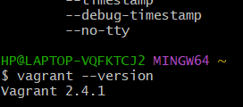

**2. Creating a New Vagrant Project:**

* Create a Project Directory:
* In your terminal, create a new directory for your Vagrant project and navigate into it:

mkdir vagrant_lab

cd vagrant_lab

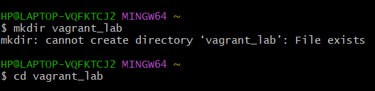

**Initialize Vagrant:**

* Run the following command to initialize a new Vagrantfile in your project directory:

vagrant init

This command will generate a Vagrantfile in the current directory.

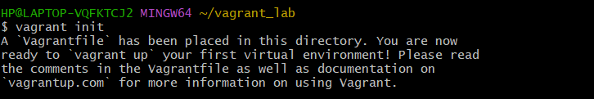

**3. Understanding the Vagrantfile:**

* Open the Vagrantfile:
* Open the Vagrantfile in a text editor of your choice.
* The Vagrantfile is a Ruby-based configuration file used to define the virtual environment.
* Basic Vagrantfile Configuration:
* Modify the Vagrantfile to configure a basic virtual machine. For example:

Vagrant.configure("2") do |config|

config.vm.box = "ubuntu/bionic64" # Specifies the base box to use (Ubuntu 18.04)

config.vm.network "private_network", type: "dhcp" # Configures a private network

config.vm.provider "virtualbox" do |vb|

vb.memory = "1024" # Allocates 1GB of RAM to the VM

end

end

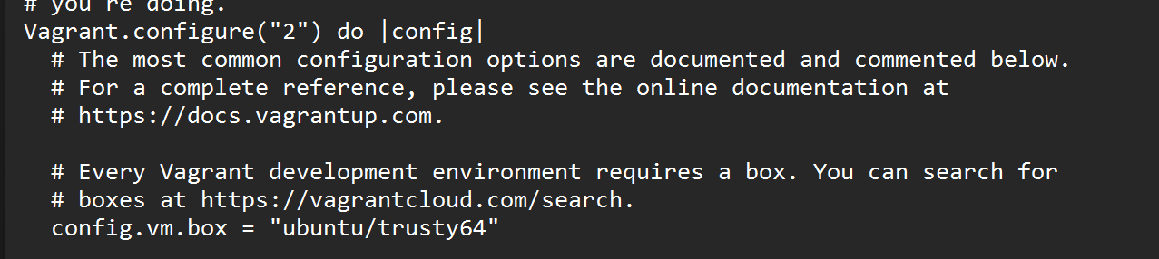

**4. Launching and Managing the VM:**

Start the VM:

In the terminal, start the VM using the following command:

vagrant up

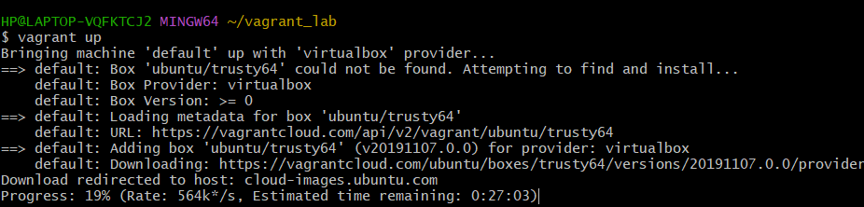

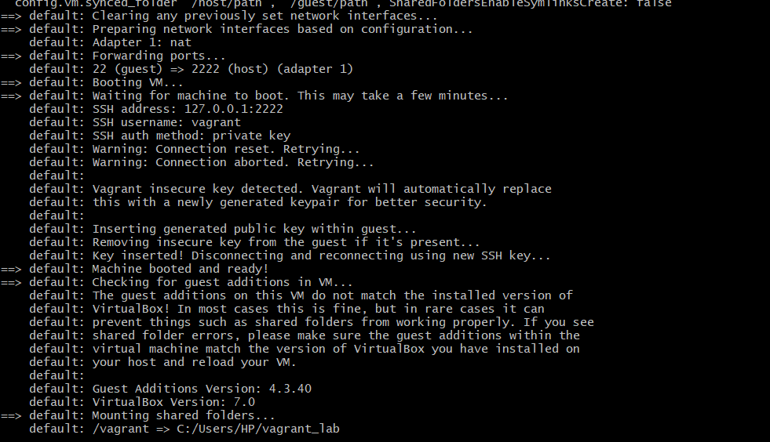

Vagrant will download the specified box (if not already downloaded) and launch the VM.

* SSH into the VM:
* Connect to the running VM using SSH:

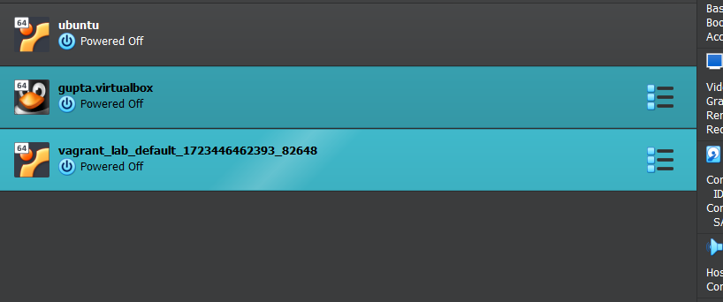

vagrant ssh

* This command will log you into the VM’s shell.
* Exploring the VM:
* Inside the VM, explore the filesystem, install packages, and run commands to understand the environment.
* Stop the VM:
* Exit the SSH session by typing exit.
* Stop the VM with the following command:

vagrant halt

Destroy the VM (optional):

To remove the VM completely, use the following command:

vagrant destroy

This will remove all traces of the VM, including any data stored on it.

Explore the benefits of using Vagrant for development and testing environments.

**Submission:**

* Submit a brief report including the Vagrantfile you configured, screenshots of the running VM, and the output of any commands run within the VM.
* Reflect on the learning experience and any challenges faced during the exercise.

This lab exercise provides a hands-on introduction to Vagrant, focusing on creating and managing virtual environments through a Vagrantfile. It offers both foundational learning and opportunities to explore more advanced features.